Supplementary Material

*Hidden Talents in Context: Cognitive performance with abstract versus ecological stimuli among adversity-exposed youth*

# Overview

This document contains three parts. First, we report our full multiverse primary analyses, including covariates (e.g., age and distractions during cognitive testing). Second, we provide visualizations for both of our secondary, exploratory analyses. The first set were focused on exploring the components of adversity dimensions. The second focuses on comparing violence $×$ task version interaction with poverty $×$ task version interaction. Third, we report descriptive statistics and bivariate correlations among all indices of adversity (unpredictability, violence, and poverty exposure).

Below are links to each of these sections:

**Primary Analyses**

* SI Table 1 (Median Effects)
* *Attention Shifting*
  + SI Figure 1 (Unpredictability)
  + SI Figure 2 (Violence Exposure)
  + SI Figure 3 (Poverty Exposure)
* *Working Memory Updating*
  + SI Figure 4 (Unpredictability)
  + SI Figure 5 (Violence Exposure)
  + SI Figure 6 (Poverty Exposure)

**Secondary Analyses**

* *Exploring Components of Adversity Dimensions*
  + SI Table 2 (Median Effects)
  + SI Table 3 (Median Simple Effects)
* *Attention Shifting*
  + SI Figure 7 (Unpredictability)
  + SI Figure 8 (Violence Exposure)
  + SI Figure 9 (poverty)
* *Working Memory Updating*
  + SI Figure 10 (Unpredictability)
  + SI Figure 11 (Violence Exposure)
  + SI Figure 12 (Poverty Exposure)
* *Comparing Violence and Poverty Exposure*
  + SI Table 4 (Median Effects)
  + SI Table 5 (Median Simple Effects)
  + SI Figure 13 (Poverty vs Violence)

**Descriptive Statistics for all Adversity Indices**

* SI Table 6 (Unpredictability)
* SI Table 7 (Violence Exposure)
* SI Table 8 (Poverty)

# Primary Analyses - Covariates

We report multiverse plots for all terms in each of our primary analyses. In brief, our mixed-effects models included the following fixed terms: the main effect of task version (abstract or ecological version, within-subjects), the main effect of childhood adversity (between-subjects), the interaction between task version and adversity measure, the main effect of age (control variable), and the main effect of test distraction ratings (control variable). Task version was grand mean centered; scores on the abstract versions were coded as -1 and 1 for the ecological version. All childhood adversity measures were standardized before model fitting and all models included a random intercept for task version nested in participants.

For a table of all results:

* SI Table 1 (Median Effects)

For attention shifting plots:

* SI Figure 1 (Unpredictability)
* SI Figure 2 (Violence Exposure)
* SI Figure 3 (Poverty Exposure)

For working memory updating plots:

* SI Figure 4 (Unpredictability)
* SI Figure 5 (Violence Exposure)
* SI Figure 6 (Poverty Exposure)

### Median Effect Sizes

**SI Table** . Median effect sizes, 95% confidence intervals, percent significant, and sample sizes for all terms predicting attention shifting.

|  | **Attention Shifting** | | | |  | **Working Memory Updating** | | | |
| --- | --- | --- | --- | --- | --- | --- | --- | --- | --- |
| **Term** | ***N*** | **𝛽** | **95% CI** | ***p* (%)** |  | ***N*** | **𝛽** | **95% CI** | ***p* (%)** |
| **Unpredictability** | | | | | | | | | |
| Age | 486 | 0.02 | [-0.04, 0.08] | 0.00% |  | 486 | 0.14 | [0.07, 0.22] | 100.00% |
| Test Environment | 486 | 0.02 | [-0.04, 0.09] | 0.00% |  | 486 | -0.10 | [-0.18, -0.03] | 62.50% |
| Task Version | 486 | 0.33 | [0.27, 0.38] | 100.00% |  | 486 | 0.08 | [0.03, 0.12] | 100.00% |
| Unpredictability | 486 | -0.05 | [-0.12, 0.01] | 25.00% |  | 486 | -0.04 | [-0.11, 0.04] | 0.00% |
| Interaction | 486 | 0.02 | [-0.03, 0.08] | 0.00% |  | 486 | 0.02 | [-0.03, 0.06] | 0.00% |
| **Violence** | | | | | | | | | |
| Age | 480 | 0.02 | [-0.04, 0.09] | 0.00% |  | 480 | 0.15 | [0.08, 0.23] | 100.00% |
| Test Environment | 480 | 0.02 | [-0.04, 0.08] | 0.00% |  | 480 | -0.11 | [-0.18, -0.03] | 75.00% |
| Task Version | 480 | 0.33 | [0.27, 0.38] | 100.00% |  | 480 | 0.08 | [0.03, 0.12] | 100.00% |
| Violence | 480 | -0.06 | [-0.12, 0.00] | 21.88% |  | 480 | -0.06 | [-0.13, 0.02] | 18.75% |
| Interaction | | | | | | | | | |
| **Poverty** |  |  |  |  |  |  |  |  |  |
| Age | 486 | 0.02 | [-0.04, 0.08] | 0.00% |  | 486 | 0.15 | [0.07, 0.22] | 100.00% |
| Test Environment | 486 | 0.02 | [-0.04, 0.08] | 0.00% |  | 486 | -0.10 | [-0.17, -0.02] | 62.50% |
| Task Version | 486 | 0.33 | [0.27, 0.38] | 100.00% |  | 486 | 0.08 | [0.03, 0.12] | 100.00% |
| Poverty | 486 | -0.03 | [0.03, -0.10] | 0.00% |  | 486 | -0.10 | [-0.03, -0.18] | 100.00% |
| Interaction | 486 | 0.02 | [0.07, -0.04] | 0.00% |  | 486 | 0.05 | [0.09, 0.00] | 53.12% |

### Unpredictability and Attention Shifting specification plot with all covariates.

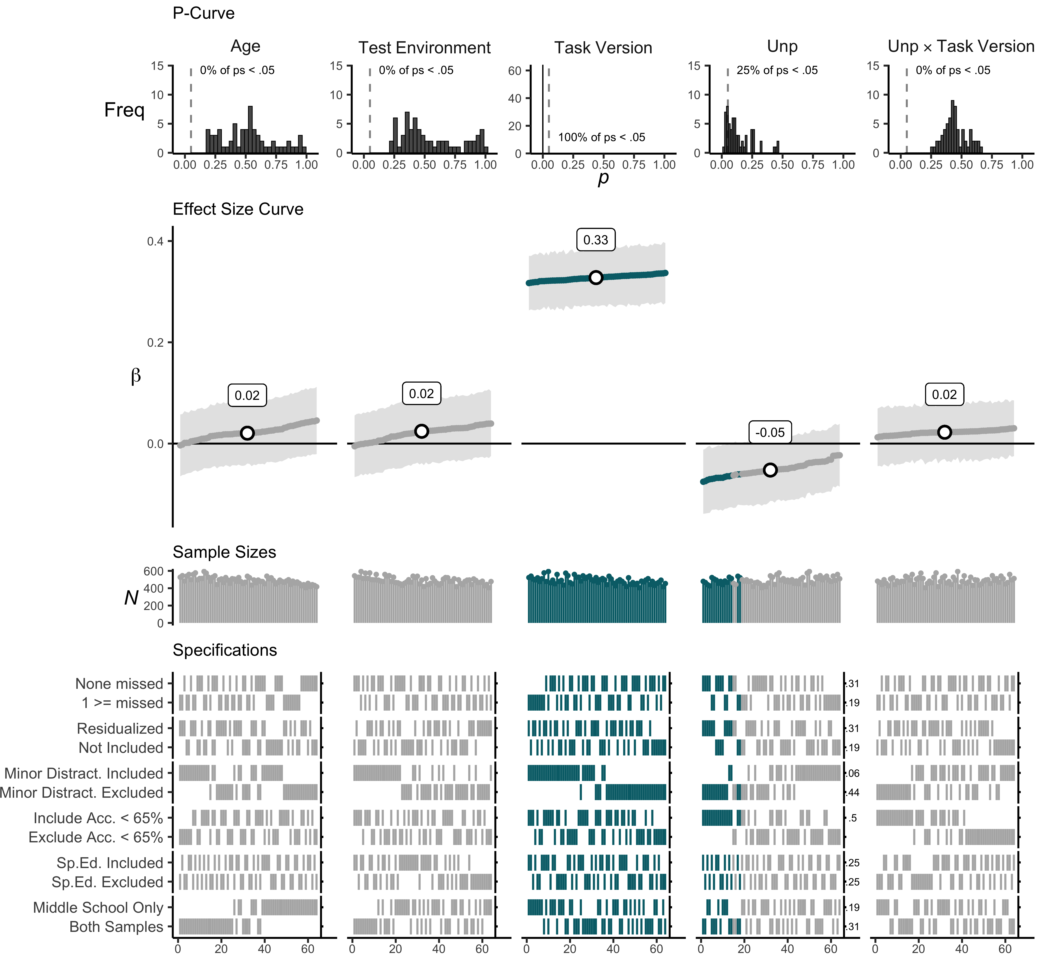

**SI Figure** . P-curves, effect size curves, sample sizes, and specification grids for each model term. Teal lines and points reflect individual multiverse effect sizes with p-values < .05.

### Violence exposure and Attention Shifting specification plot with all covariates.

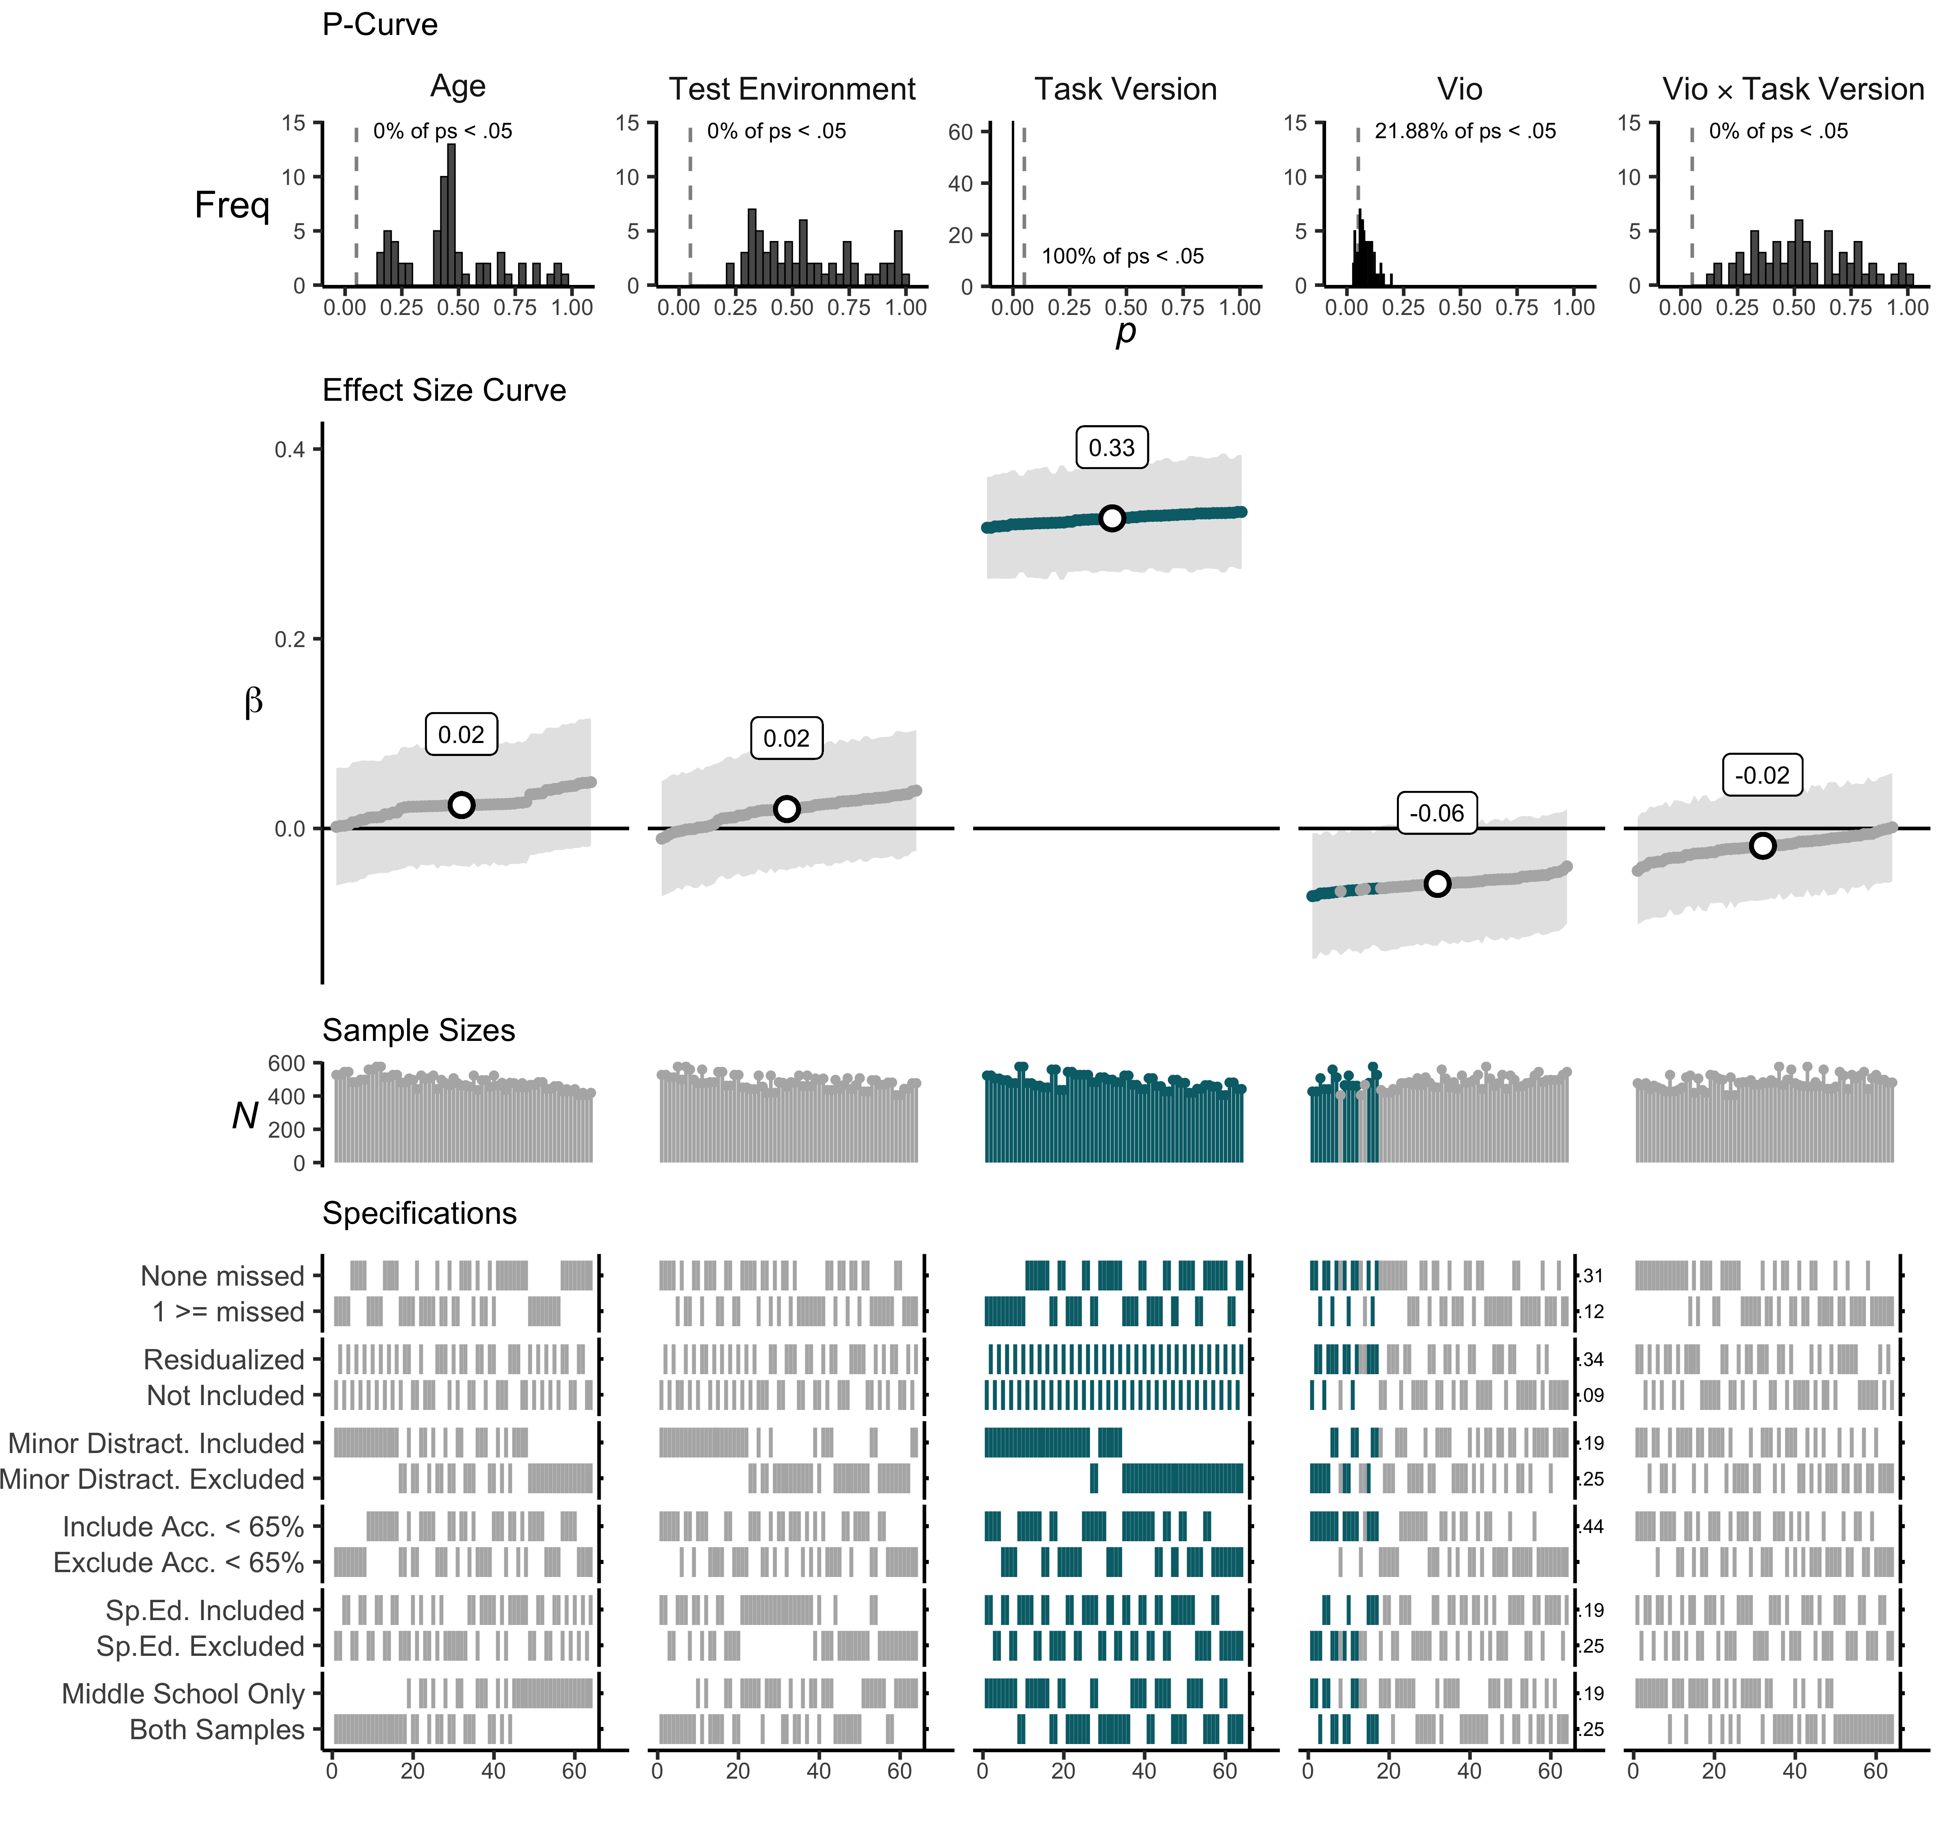

**SI Figure** . P-curves, effect size curves, sample sizes, and specification grids for each model term. Teal lines and points reflect individual multiverse effect sizes with p-values < .05.

### Poverty and Attention Shifting specification plot with all covariates.

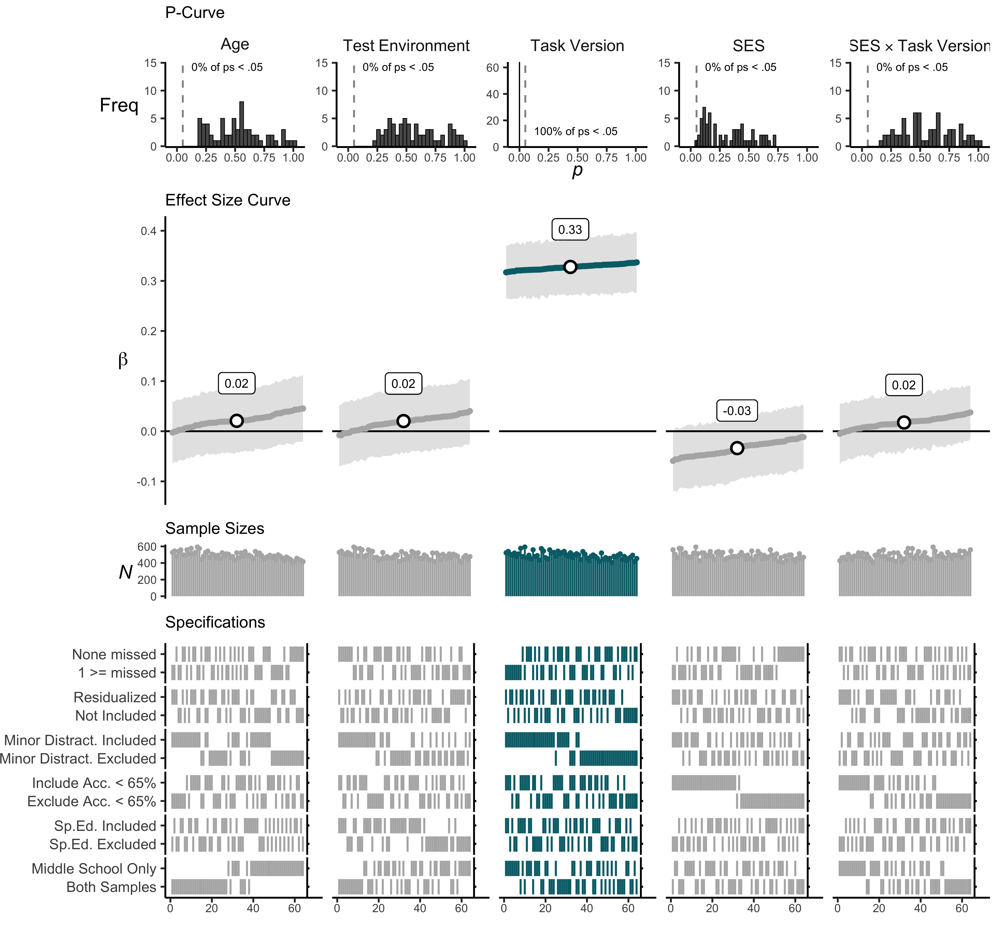

**SI Figure** . P-curves, effect size curves, sample sizes, and specification grids for each model term. Teal lines and points reflect individual multiverse effect sizes with p-values < .05.

### Unpredictability and working memory updating specification plot with all covariates.

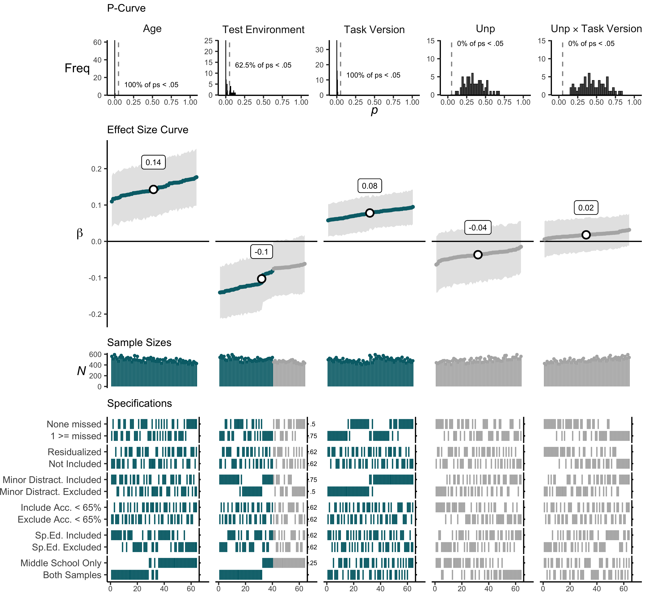

**SI Figure** . P-curves, effect size curves, sample sizes, and specification grids for each model term. Teal lines and points reflect individual multiverse effect sizes with p-values < .05.

### Violence exposure and working memory updating specification plot with all covariates.

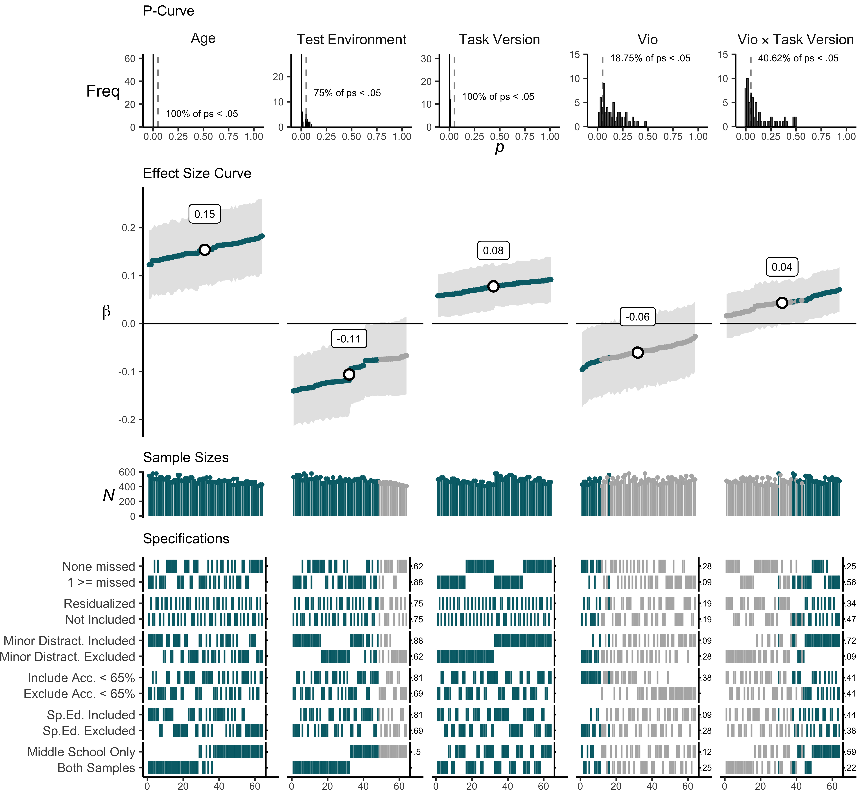

**SI Figure** . P-curves, effect size curves, sample sizes, and specification grids for each model term. Teal lines and points reflect individual multiverse effect sizes with p-values < .05.

### Poverty and working memory updating specification plot with all covariates.

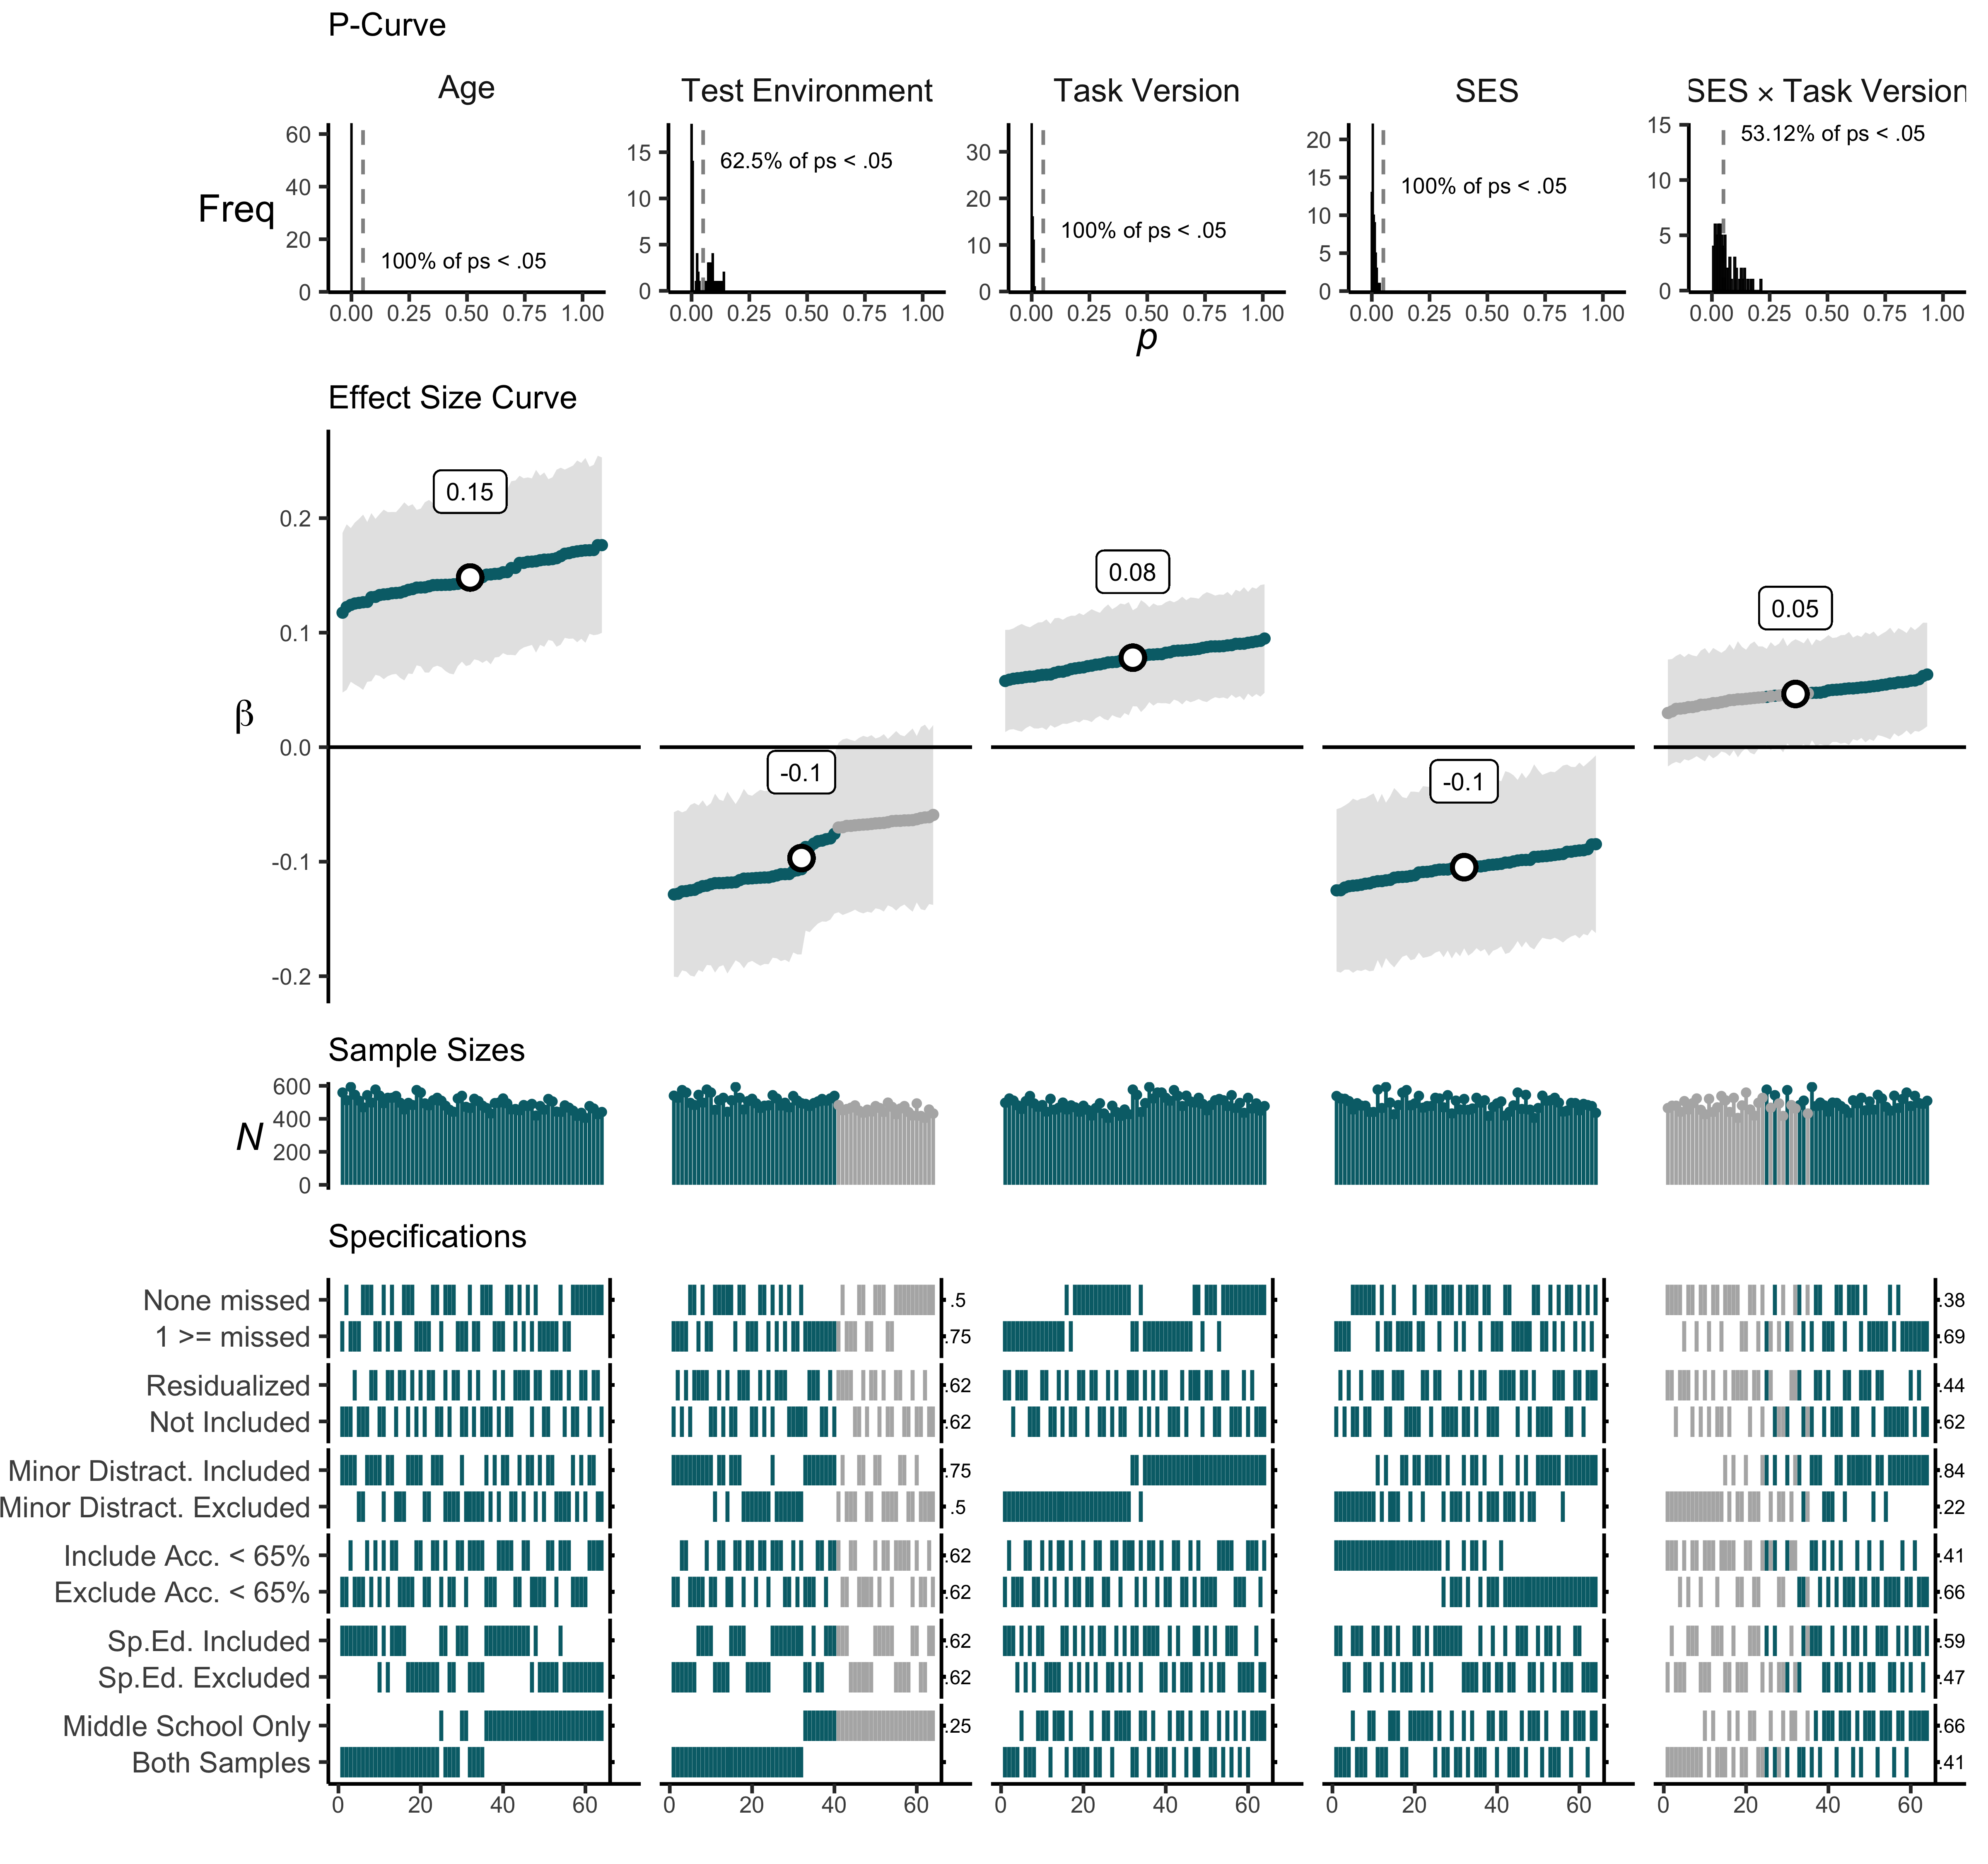

**SI Figure** . P-curves, effect size curves, sample sizes, and specification grids for each model term. Teal lines and points reflect individual multiverse effect sizes with p-values < .05.

# Secondary Analyses

We followed-up our primary analyses with two sets of secondary, exploratory analyses. Secondary analysis plans were uploaded to OSF prior to conducting them (see <https://osf.io/7fu35/> and <https://osf.io/wcauf/>). These analyses were focused on two questions. First, in contrast to prior work (i.e., Mittal et al., 2015; Young et al., 2018) we found no interactive effect for environmental unpredictability and task version on attention shifting or working memory updating performance (but some evidence for main effects on attention shifting). However, prior work has measured retrospective perceptions of environmental unpredictability whereas the current combined perceptions with objective, interview-based measures. Thus, one possibility is specific components of our adversity measures may have unique effects on attention shifting and working memory updating. To address this, we expanded our multiverse approach to include each version of our independent variables as a arbitrary data decision.

The second question focused on the interactive effects of task version $×$ violence exposure and task version $×$ poverty on working memory updating performance. Specifically, primary analyses revealed an equalization effect for both violence and poverty exposure. However, because violence and poverty were not included in the same underlying model, the extent to which they are independent is unclear. For example, one possibility is that violence and poverty exposure exert unique and independent effects on working memory updating. Alternatively, these interactions could reflect the same effect. To test this question, we ran a focused multiverse analysis with the same controls, main effects of task version, poverty and violence, and two interaction terms: task version × violence exposure and task version × poverty in the same model. If violence exposure and poverty interact independently with task version, both interactions should remain significant. However, if they overlap, one effect may be driving the other.

## Exploring Components of Adversity Dimensions

We ran an expanded multiverse analysis to explore the effects of each component making up our adversity composites. Environmental unpredictability contained two components, perceived unpredictability (self-reported) and an interview-based measure tabulating family disruptions, parental transitions and residential moves. Violence exposure contained two self-reports: neighborhood violence and exposure to and involvement in violence. Poverty exposure contained three components: parental education/occupation, perceived resource scarcity, and school-coded economic disadvantage (e.g., fee waivers, free or reduced priced lunch, and homelessness).

For this expanded multiverse approach, we retained all original data processing decisions and added an adversity component as an additional decision. For environmental unpredictability, we analyzed both unpredictability components and the composite (composite analyses are redundant with primary analyses but were retained for comparison purposes), which resulted in 192 analyses (64 original $×$ three versions of unpredictability). The same approach was applied to violence exposure (3 violence exposure variables, 192 analyses) and poverty exposure (4 poverty variables, 256 analyses).

**For tables of all median effects and simple effects:**

* SI Table 2 (Median Effects)
* SI Table 3 (Simple Effects)

**For attention shifting plots:**

* SI Figure 7 (Unpredictability)
* SI Figure 8 (Violence Exposure)
* SI Figure 9 (Poverty Exposure)

**For working memory updating plots:**

* SI Figure 10 (Unpredictability)
* SI Figure 11 (Violence Exposure)
* SI Figure 12 (Poverty Exposure)

### Median Effect Sizes

**SI Table** . Median effect sizes, 95% confidence intervals, percent significant, and sample sizes for main effects of adversity components and interactions with task version for attention shifting and working memory updating.

|  | **Attention Shifting** | | | |  | **Working Memory Updating** | | | |
| --- | --- | --- | --- | --- | --- | --- | --- | --- | --- |
|  | ***N*** | **𝛽** | **95% CI** | ***p* (%)** |  | ***N*** | **𝛽** | **95% CI** | ***p* (%)** |
| **Unpredictability** | | | | | | | | | |
| Composite | 486 | -0.05 | [-0.12, 0.01] | 25.00% |  | 486 | -0.04 | [-0.11, 0.04] | 0.00% |
| Composite x Task Version | 486 | 0.02 | [-0.03, 0.08] | 0.00% |  | 486 | 0.02 | [-0.03, 0.06] | 0.00% |
| Interview | 486 | -0.02 | [-0.08, 0.05] | 0.00% |  | 486 | -0.02 | [-0.10, 0.05] | 0.00% |
| Interview x Task Version | 486 | 0.03 | [-0.02, 0.09] | 0.00% |  | 486 | 0.02 | [-0.03, 0.07] | 0.00% |
| Perceived | 480 | -0.08 | [-0.14, -0.01] | 90.62% |  | 480 | -0.04 | [-0.12, 0.03] | 0.00% |
| Perceived x Task Version | 480 | 0.01 | [-0.05, 0.06] | 0.00% |  | 480 | 0.01 | [-0.04, 0.06] | 0.00% |
| **Violence** | | | | | | | | | |
| Composite | 480 | -0.06 | [-0.12, 0.00] | 21.88% |  | 480 | -0.06 | [-0.13, 0.02] | 18.75% |
| Composite x Task Version | 480 | -0.02 | [-0.08, 0.04] | 0.00% |  | 480 | 0.04 | [-0.00, 0.09] | 40.62% |
| Fighting | 480 | -0.04 | [-0.10, 0.03] | 0.00% |  | 480 | -0.06 | [-0.14, 0.01] | 20.31% |
| Fighting x Task Version | 480 | -0.04 | [-0.10, 0.02] | 0.00% |  | 480 | 0.06 | [0.01, 0.10] | 75.00% |
| Neighborhood | 480 | -0.07 | [-0.13, -0.00] | 65.62% |  | 480 | -0.04 | [-0.12, 0.03] | 0.00% |
| Neighborhood x Task Version | 480 | 0.01 | [-0.05, 0.06] | 0.00% |  | 480 | 0.02 | [-0.02, 0.07] | 0.00% |
| **Poverty** | | | | | | | | | |
| Composite | 486 | -0.03 | [0.03, -0.10] | 0.00% |  | 486 | -0.10 | [-0.03, -0.18] | 100.00% |
| Composite x Task Version | 486 | 0.02 | [0.07, -0.04] | 0.00% |  | 486 | 0.05 | [0.09, 0.00] | 53.12% |
| Interview | 486 | -0.03 | [0.03, -0.10] | 0.00% |  | 486 | -0.11 | [-0.03, -0.18] | 100.00% |
| Parents x Task Version | 486 | 0.03 | [0.09, -0.02] | 0.00% |  | 486 | 0.04 | [0.09, -0.00] | 26.56% |
| Perceived | 480 | -0.02 | [0.04, -0.09] | 0.00% |  | 480 | -0.04 | [0.03, -0.12] | 0.00% |
| Perceived x Task Version | 480 | -0.01 | [0.05, -0.06] | 0.00% |  | 480 | 0.02 | [0.06, -0.03] | 0.00% |
| School | 462 | -0.02 | [0.04, -0.09] | 0.00% |  | 462 | -0.07 | [0.00, -0.15] | 42.19% |
| School x Task Version | 462 | 0.01 | [0.06, -0.05] | 0.00% |  | 462 | 0.04 | [0.09, -0.01] | 18.75% |

### Median Simple Effects

**SI Table** . Median simple slopes (unstandardized) and percent significant for adversity component interactions with task version for attention shifting and working memory updating.

|  | **Task Version** | | | |  | **Adversity Exposure** | | | |
| --- | --- | --- | --- | --- | --- | --- | --- | --- | --- |
|  | ***b* (abstract)** | ***p* (%)** | ***b* (ecological)** | ***p* (%)** |  | ***b* (low)** | ***p* (%)** | ***b* (high)** | ***p* (%)** |
| **Attention Shifting** | | | | | | | | | |
| Unp Composite | -18.22 | 10.94% | -7.29 | 0.00% |  | 74.14 | 100.00% | 84.88 | 100.00% |
| Unp Interview | -12.24 | 0.00% | 4.05 | 0.00% |  | 71.80 | 100.00% | 87.24 | 100.00% |
| Unp Perceived | -20.28 | 40.62% | -18.05 | 25.00% |  | 77.57 | 100.00% | 80.45 | 100.00% |
| Vio Composite | -9.62 | 0.00% | -18.61 | 25.00% |  | 83.60 | 100.00% | 74.34 | 100.00% |
| Vio Fighting | 1.59 | 0.00% | -18.79 | 12.50% |  | 88.98 | 100.00% | 69.03 | 100.00% |
| Vio Neighborhood | -17.78 | 9.38% | -14.78 | 15.62% |  | 77.29 | 100.00% | 80.58 | 100.00% |
| Poverty Composite | -12.51 | 0.00% | -4.08 | 0.00% |  | 75.17 | 100.00% | 83.63 | 100.00% |
| Poverty Interview | -16.18 | 25.00% | 0.54 | 0.00% |  | 70.88 | 100.00% | 88.16 | 100.00% |
| Poverty Perceived | -4.07 | 0.00% | -8.24 | 0.00% |  | 81.02 | 100.00% | 77.00 | 100.00% |
| Poverty School | -7.35 | 0.00% | -4.31 | 0.00% |  | 77.53 | 100.00% | 80.69 | 100.00% |
| **Working Memory Updating** | | | | | | | | | |
| Unp Composite | -0.95 | 0.00% | -0.32 | 0.00% |  | 1.01 | 28.12% | 1.68 | 100.00% |
| Unp Interview | -0.76 | 0.00% | -0.08 | 0.00% |  | 1.00 | 25.00% | 1.75 | 100.00% |
| Unp Perceived | -0.90 | 0.00% | -0.56 | 0.00% |  | 1.13 | 48.44% | 1.48 | 100.00% |
| Vio Composite | -1.80 | 81.25% | -0.31 | 0.00% |  | 0.58 | 0.00% | 2.08 | 100.00% |
| Vio Fighting | -2.04 | 96.88% | -0.14 | 0.00% |  | 0.36 | 0.00% | 2.27 | 100.00% |
| Vio Neighborhood | -1.15 | 3.12% | -0.36 | 0.00% |  | 0.92 | 15.62% | 1.74 | 98.44% |
| Poverty Composite | -2.66 | 100.00% | -1.03 | 7.81% |  | 0.56 | 0.00% | 2.12 | 100.00% |
| Poverty Interview | -2.58 | 100.00% | -1.11 | 3.12% |  | 0.63 | 0.00% | 2.17 | 100.00% |
| Poverty Perceived | -1.07 | 0.00% | -0.44 | 0.00% |  | 1.06 | 32.81% | 1.58 | 92.19% |
| Poverty School | -1.97 | 92.19% | -0.55 | 0.00% |  | 0.79 | 0.00% | 2.19 | 100.00% |

### Unpredictability components and attention shifting multiverse results.

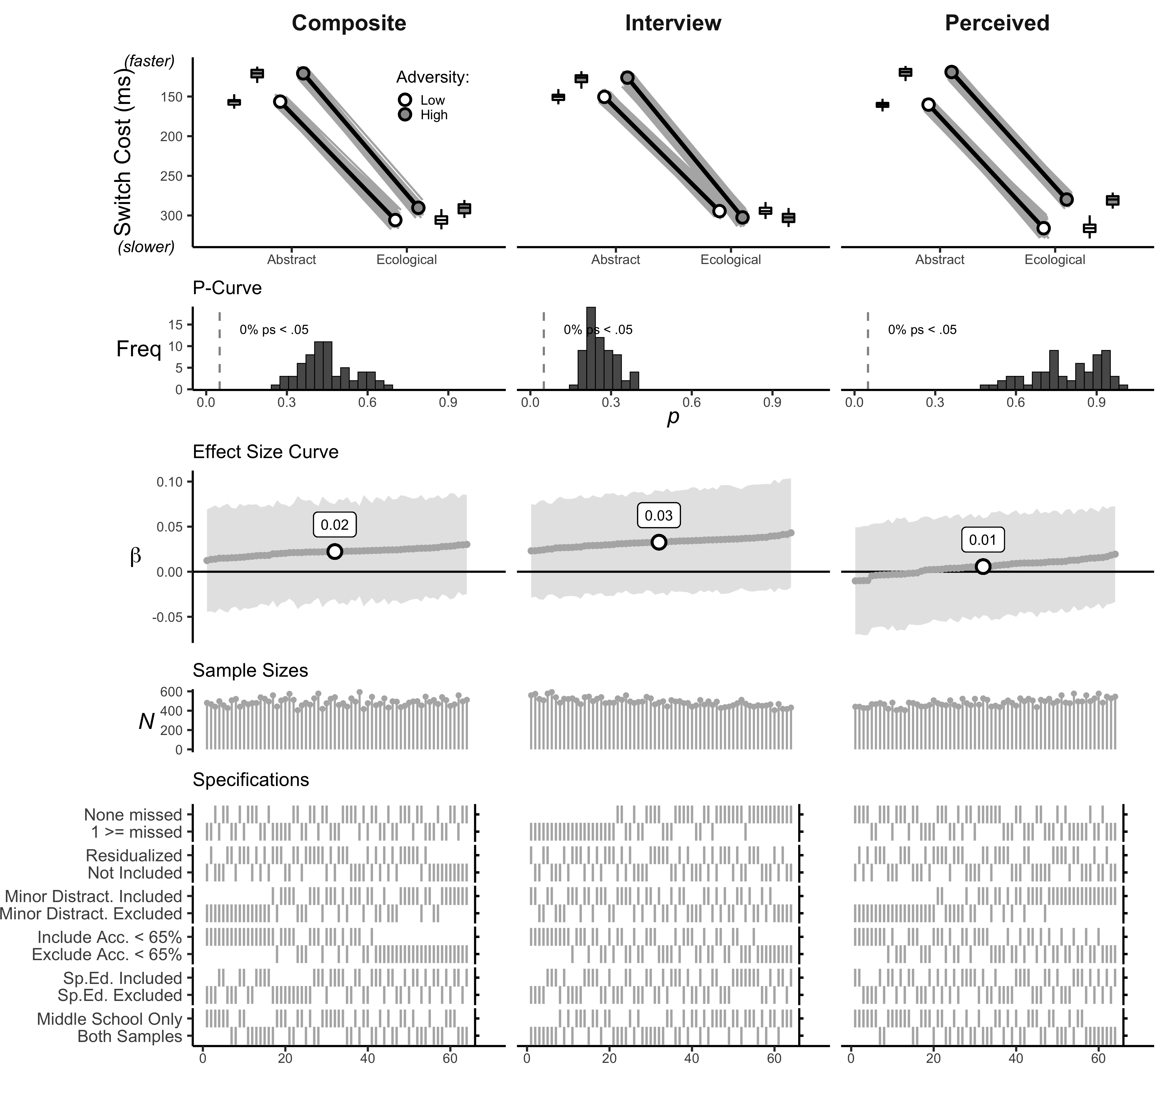

**SI Figure** . Interaction plots, p-curves, effect size curves, sample sizes, and specification grids task version by unpredictability components.

### Violence exposure components and attention shifting multiverse results.

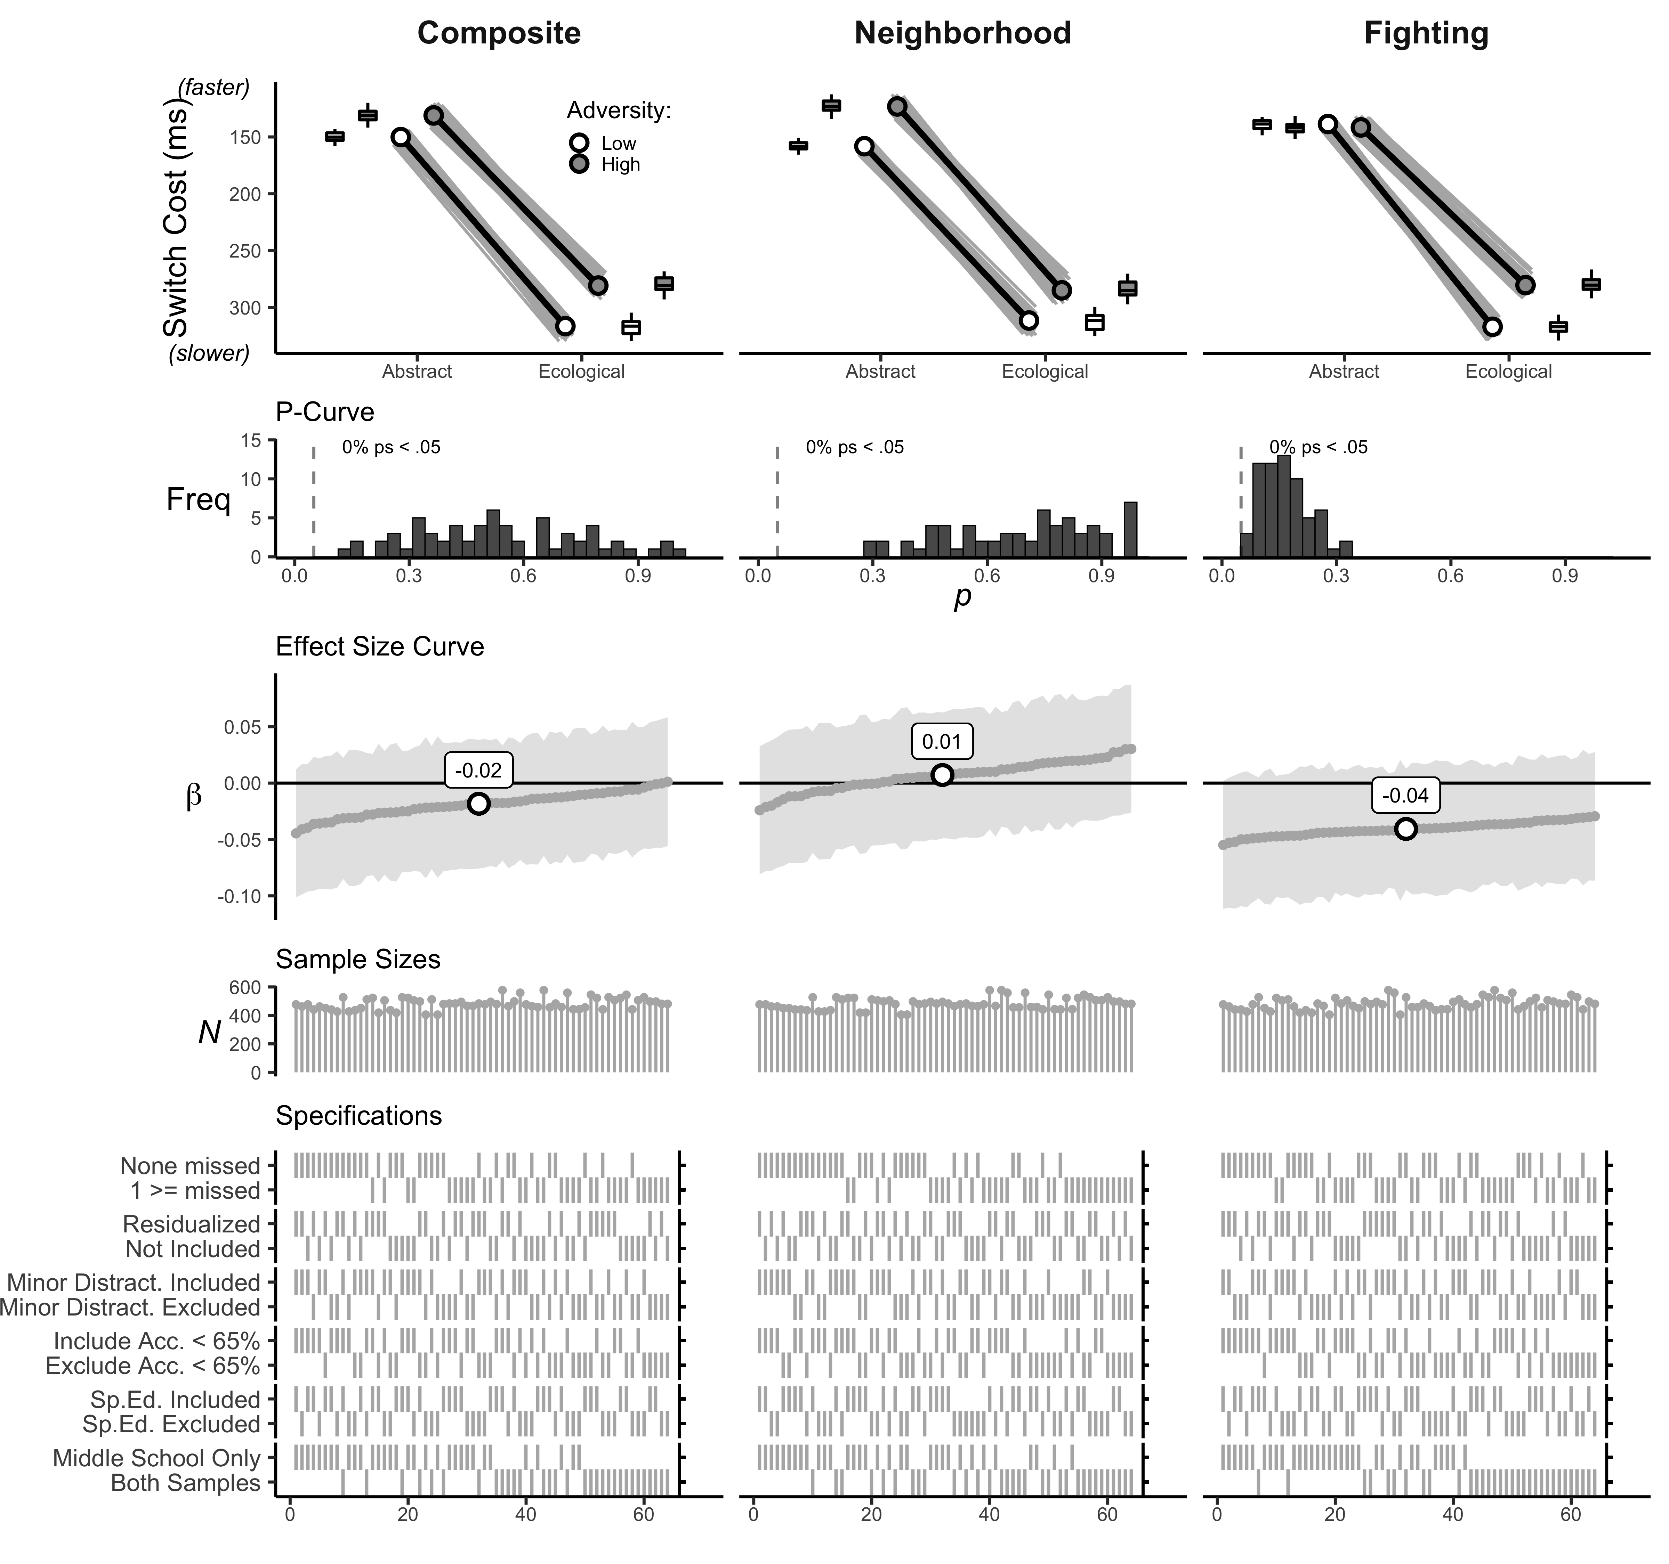

**SI Figure** . Interaction plots, p-curves, effect size curves, sample sizes, and specification grids for task version by violence exposure component interactions. Teal lines and points reflect individual multiverse effect sizes with p-values < .05.

### Poverty components and attention shifting multiverse results.

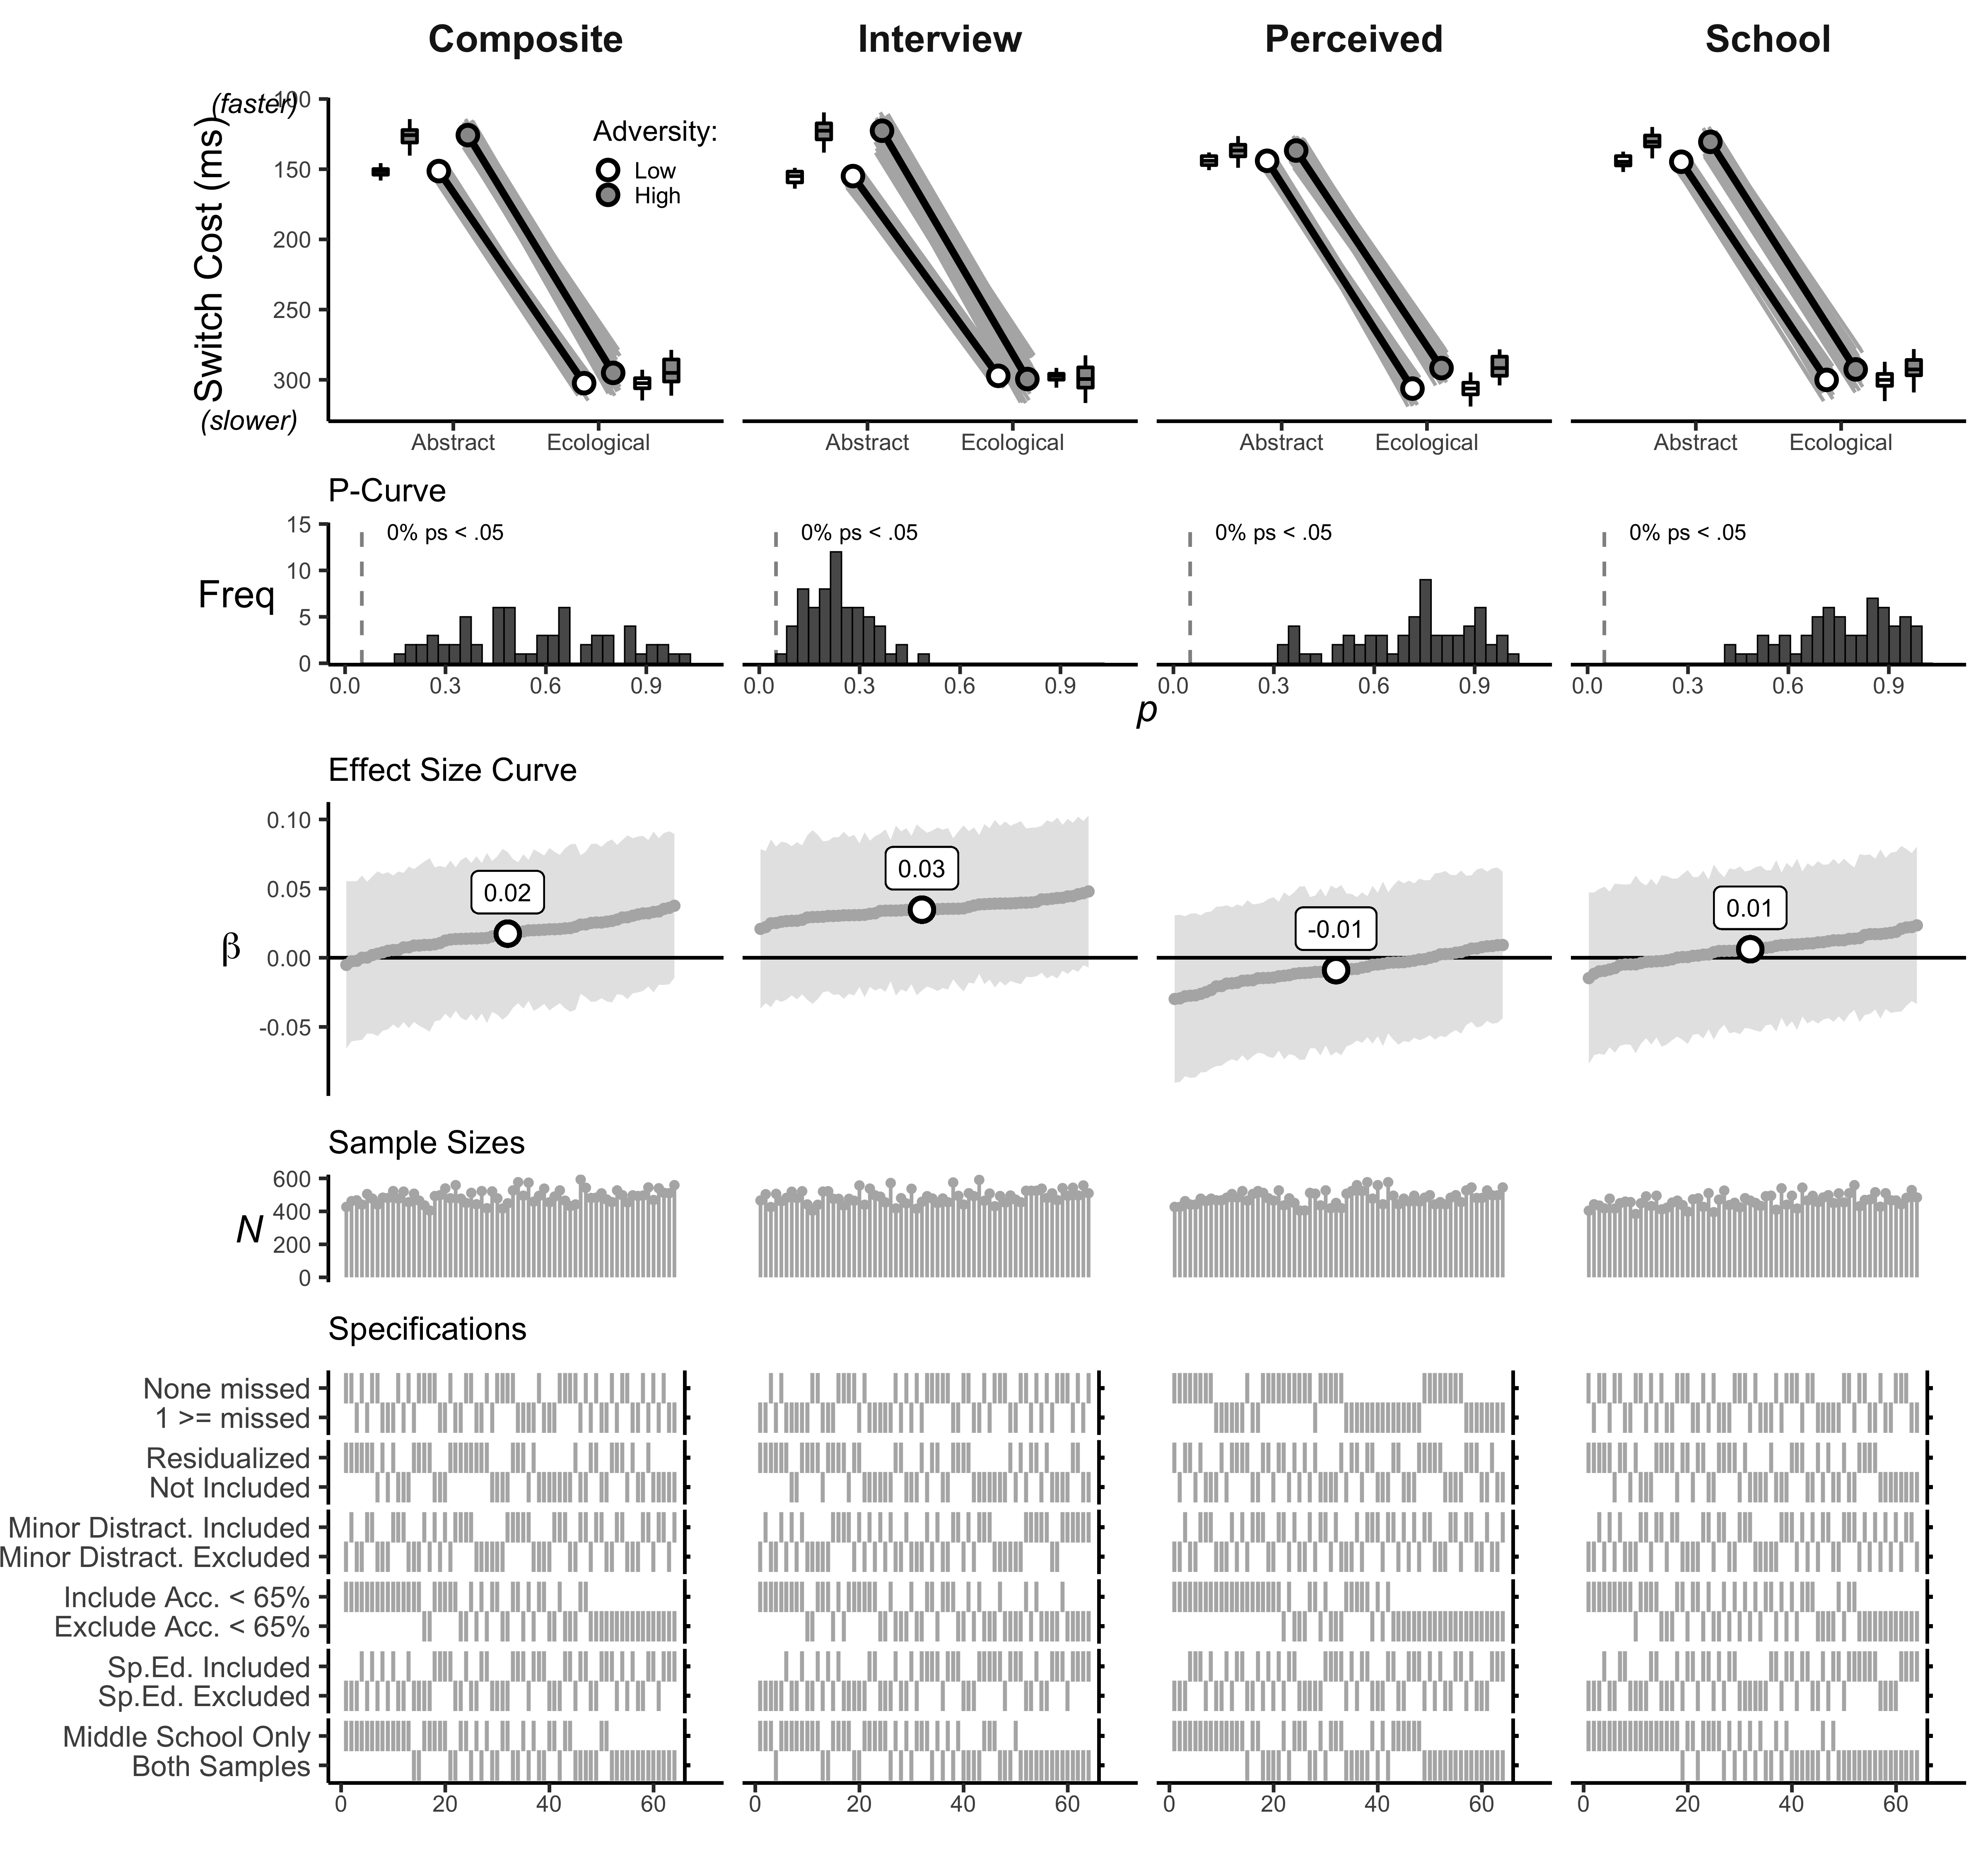

**SI Figure** . Interaction plots, p-curves, effect size curves, sample sizes, and specification grids for task version by Poverty component interactions. Teal lines and points reflect individual multiverse effect sizes with p-values < .05.

### Unpredictability components and working memory updating multiverse results.

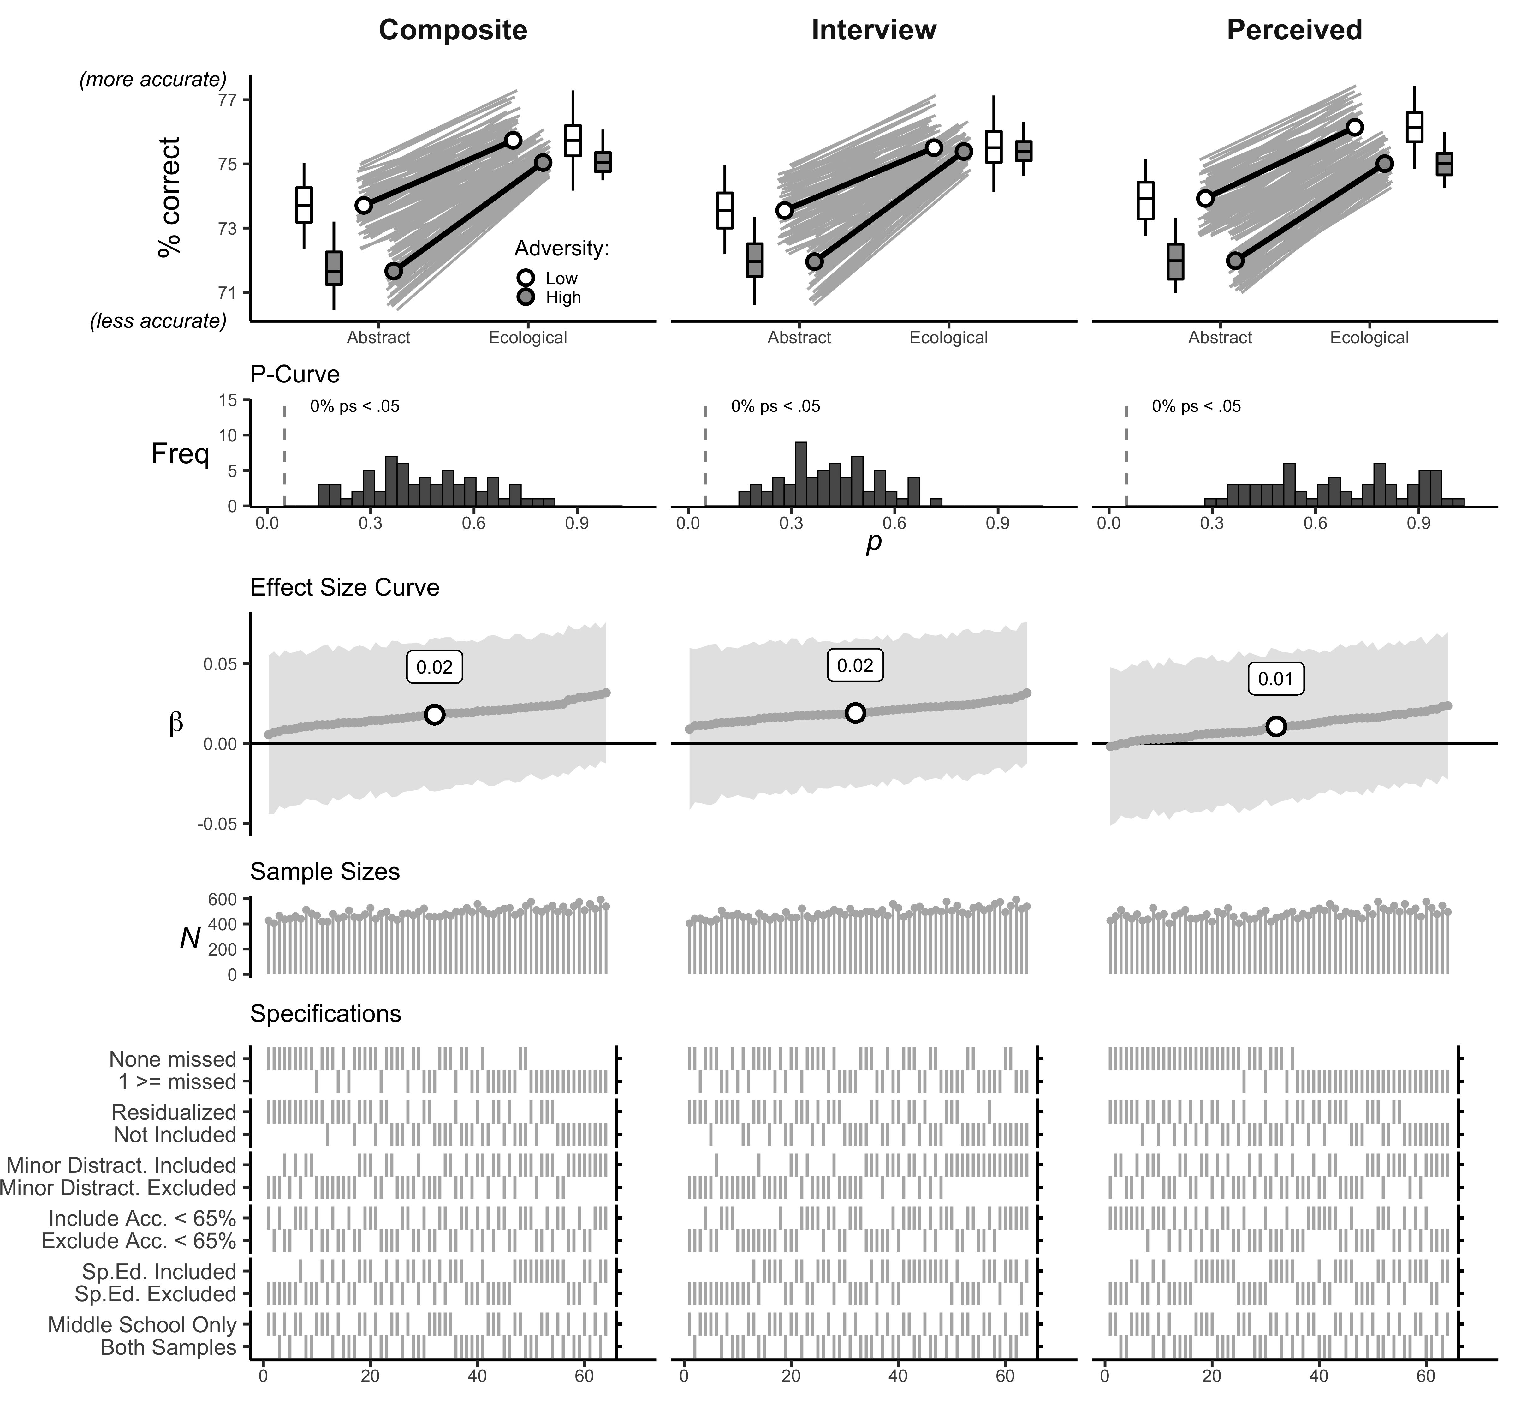

**SI Figure** . Interaction plots, p-curves, effect size curves, sample sizes, and specification grids for task version by unpredictability component interactions. Teal lines and points reflect individual multiverse effect sizes with p-values < .05.

### Violence exposure components and working memory updating multiverse results.

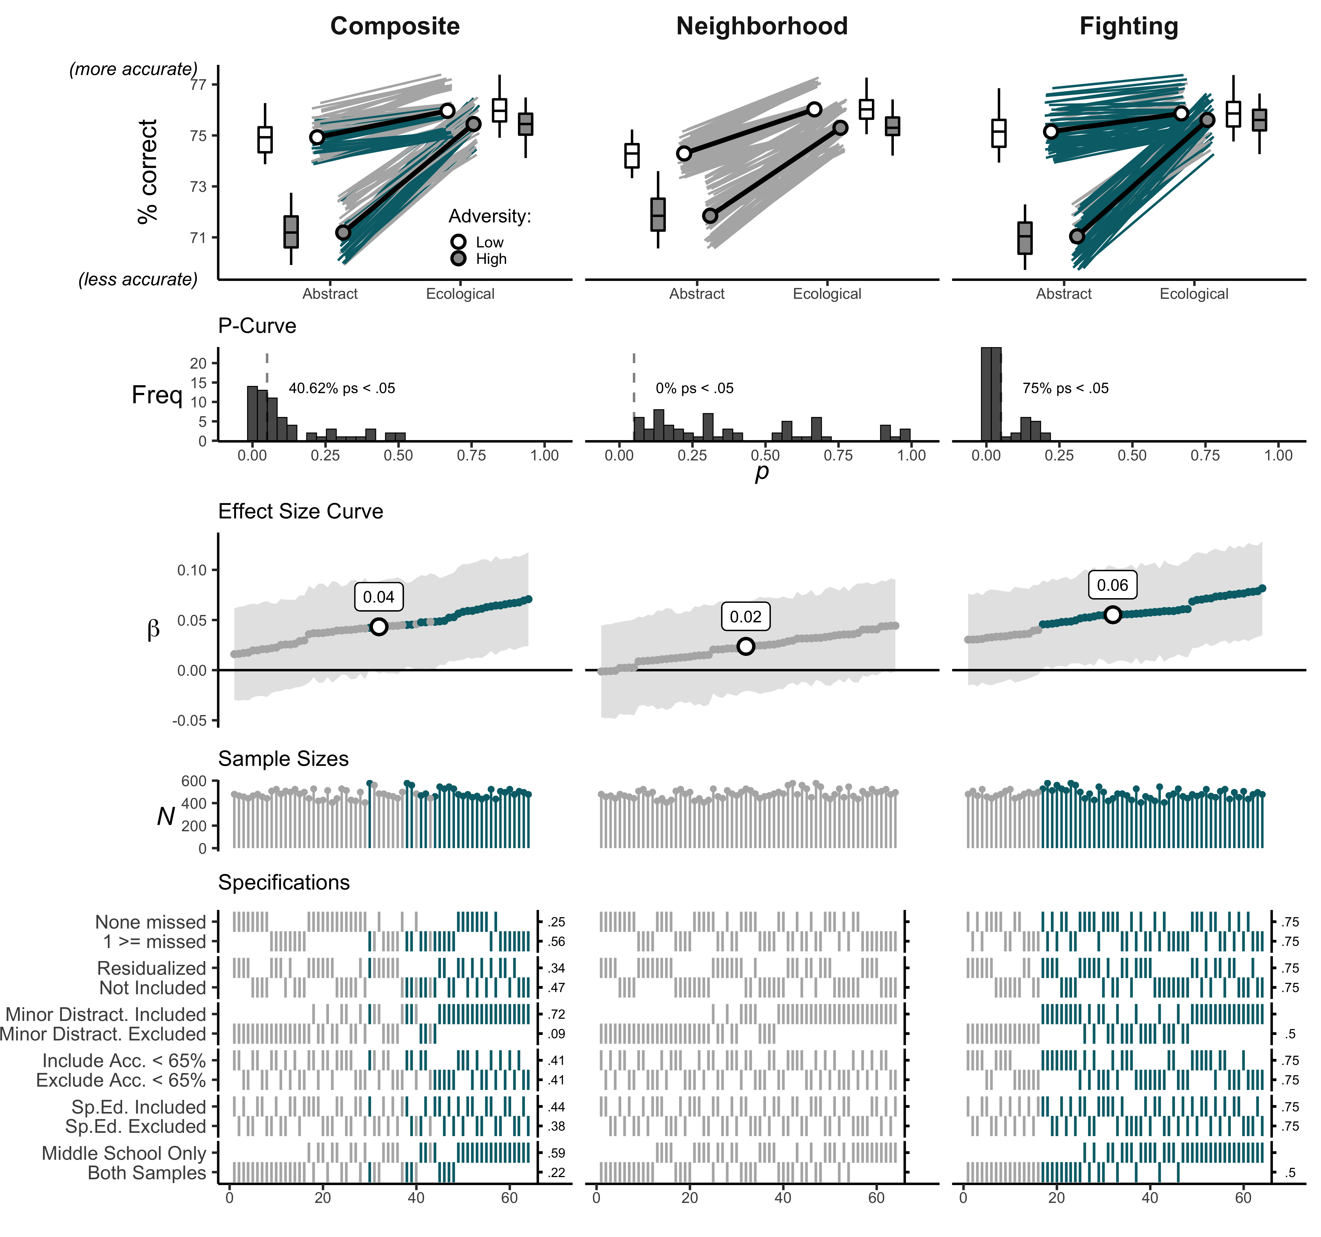

**SI Figure** . Interaction plots, p-curves, effect size curves, sample sizes, and specification grids for task version by violence exposure component interactions. Teal lines and points reflect individual multiverse effect sizes with p-values < .05.

### Poverty components and working memory updating multiverse results.

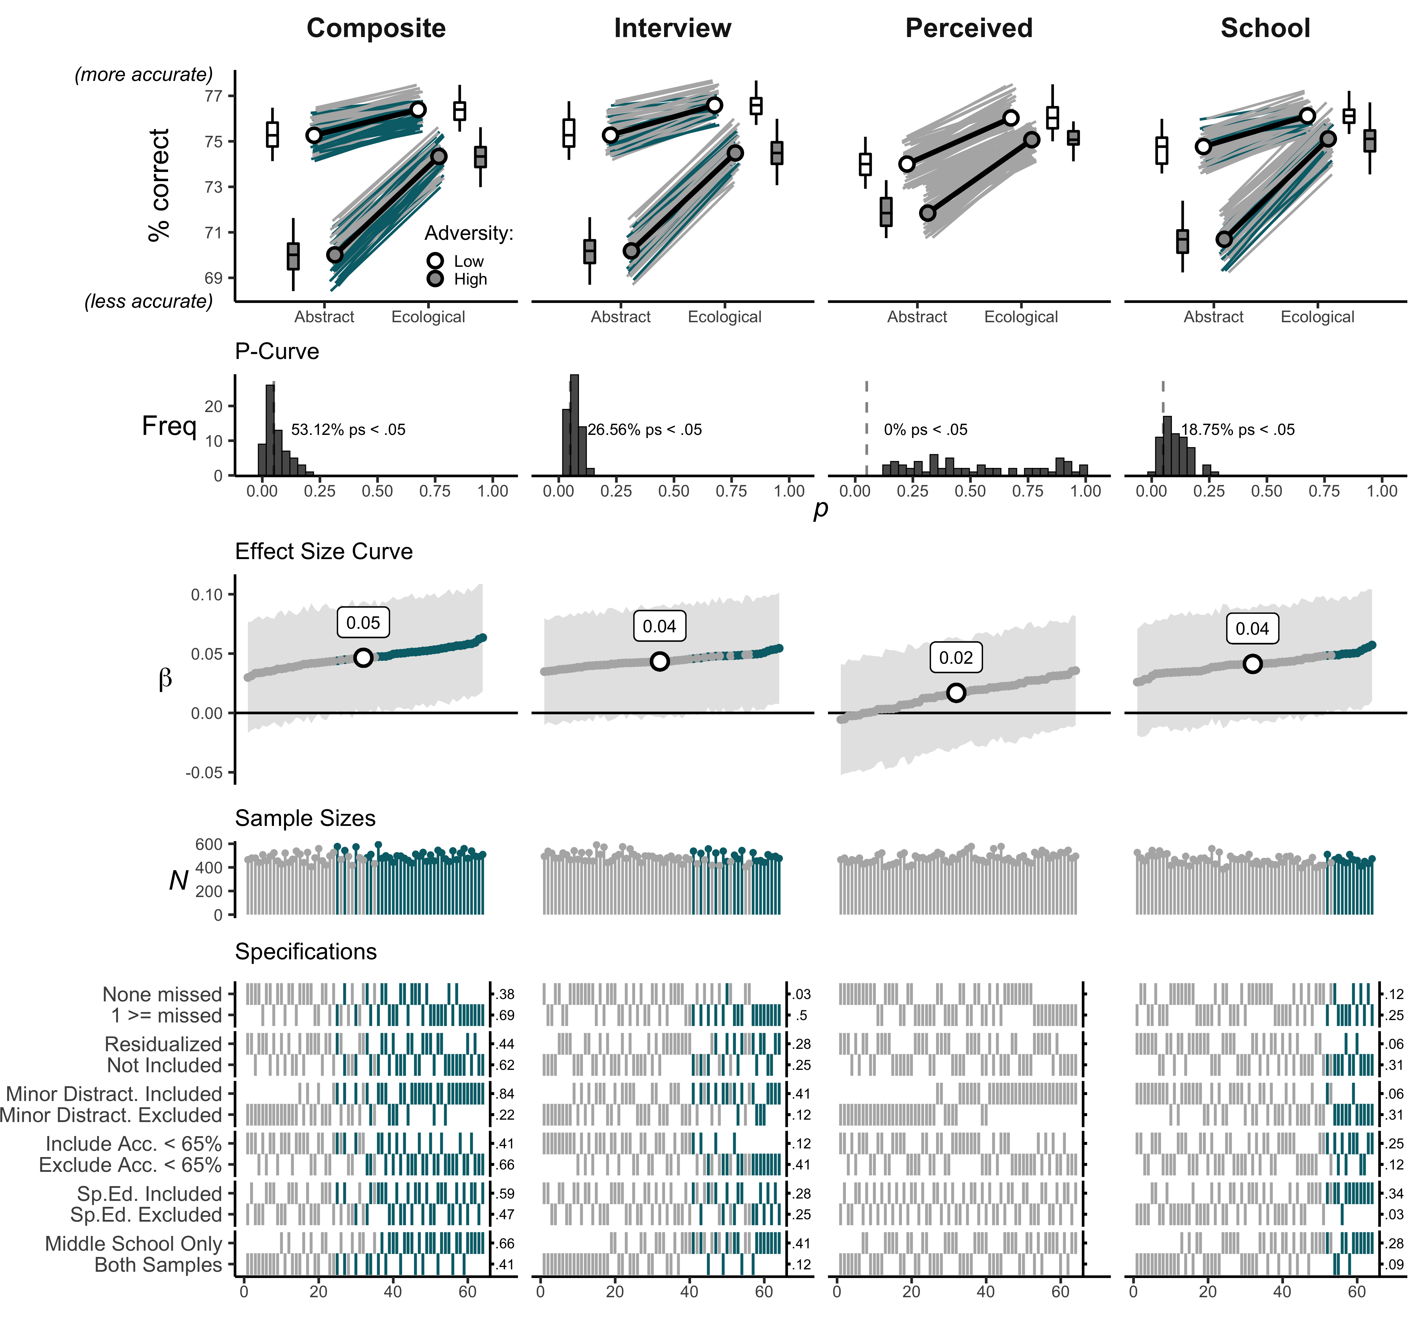

**SI Figure** . Interaction plots, p-curves, effect size curves, sample sizes, and specification grids for task version by Poverty component interactions. Teal lines and points reflect individual multiverse effect sizes with p-values < .05.

## Comparing Violence and Poverty Exposure

Our second set of secondary analyses focused on the interactive effects of task version × violence exposure and task version × poverty exposure on working memory updating performance. Specifically, primary analyses revealed an equalization effect for both violence and poverty exposure. However, because violence and poverty were not included in the same underlying model, it is unclear if each interaction is independent from the other. For example, one possibility is that violence exposure and poverty exert unique and independent effects on working memory updating. Alternatively, these interactions could reflect the same effect. To test this question, we ran a focused multiverse analysis with the same controls, main effects of task version, Poverty and violence, and two interaction terms: task version × violence exposure and task version × poverty exposure in the same model.

For results see:

* SI Table 4 (Median Effects)
* [SI Table 5]($tab5) (Simple Effects)
* SI Figure 13 (Plots)

### Median Effects

**SI Table** . Median effect sizes, 95% confidence intervals, percent significant, and sample sizes for multiverse analyses comparing Poverty by task version and violence by task version interactions.

|  | 𝛽 | 95% CI | *p* (%) | median *N* |
| --- | --- | --- | --- | --- |
| Age | 0.15 | [0.08, 0.23] | 100.00% | 480 |
| Test Environment | -0.10 | [-0.17, -0.02] | 62.50% | 480 |
| Task Version | 0.08 | [0.03, 0.12] | 100.00% | 480 |
| Poverty | -0.10 | [-0.02, -0.17] | 90.62% | 480 |
| Violence | -0.03 | [-0.11, 0.05] | 0.00% | 480 |
| Poverty x Task Version | 0.03 | [0.08, -0.01] | 0.00% | 480 |
| Violence x Task Version | 0.03 | [-0.02, 0.08] | 14.06% | 480 |
|  | | | | |

### Median Simple Effects

**SI Table** . Median simple slopes (unstandardized) and percent significant for multiverse analyses comparing Poverty by task version and violence by task version interactions.

|  | **Task Version** | | | |  | **Adversity Exposure** | | | |
| --- | --- | --- | --- | --- | --- | --- | --- | --- | --- |
|  | ***b* (abstract)** | ***p* (%)** | ***b* (ecological)** | ***p* (%)** |  | ***b* (low)** | ***p* (%)** | ***b* (high)** | ***p* (%)** |
| Violence | -1.05 | 1.56% | 0.07 | 0.00% |  | 0.77 | 0.00% | 1.89 | 100.00% |
| Poverty | 2.27 | 100.00% | 1.02 | 0.00% |  | 0.76 | 0.00% | 1.91 | 100.00% |
|  | | | | | | | | | |

### Multiverse results for Poverty and violence exposure interactions with task version in the same model.

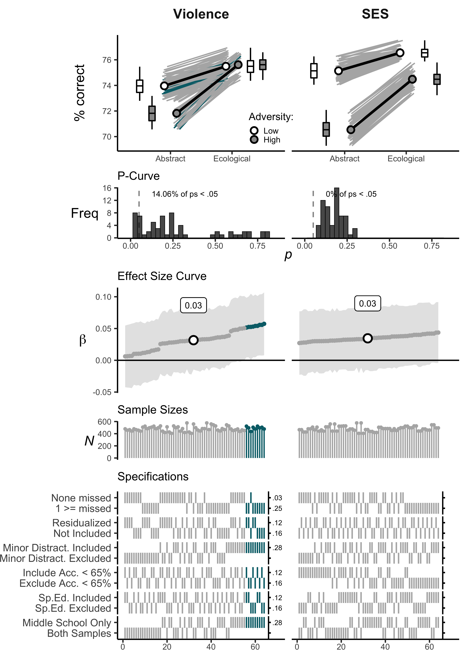

**SI Figure** . Interaction plots, p-curves, effect size curves, sample sizes, and specification grids for task version by violence and task version by poverty

# Descriptive Statistics of Adversity Indices

**SI Table** . Correlations and descriptive statistics for interview-based and perceived unpredictability.

|  | 1 | 2 | 3 | 4 |
| --- | --- | --- | --- | --- |
| 1. Family Disruption (interview) | - | 613 | 613 | 596 |
| 2. Parental Transitions (interview) | 0.71** | - | 618 | 601 |
| 3. Residential Moves (interview) | 0.44** | 0.43** | - | 601 |
| 4. Perceived (self-report | 0.45** | 0.45** | 0.34** | - |
| Min | 0.00 | 0.00 | 0.00 | 1.00 |
| Median | 0.00 | 0.00 | 1.00 | 1.83 |
| Max | 3.00 | 10.00 | 9.00 | 4.67 |
| Range | 3.00 | 10.00 | 9.00 | 3.67 |
| Mean | 0.85 | 1.36 | 1.35 | 1.99 |
| SD | 1.05 | 1.80 | 1.66 | 0.73 |
| Possible Range | 0-3 | - | - | 1-5 |
| *Note: * p* < .05, *\*\* p* < .01 | | | | |
|  | | | | |

**SI Table** . Correlations and descriptive statistics for witnessing and involvement in fights and perceived neighborhood violence. Teal lines and points reflect individual multiverse effect sizes with p-values < .05.

|  | 1 | 2 | 3 |
| --- | --- | --- | --- |
| 1. Witnessing Fights | - | 576 | 601 |
| 2. Involvement in Fights | 0.53** | - | 576 |
| 3. Perceived Neighborhood Violence | 0.55** | 0.49** | - |
| Min | 1.00 | 1.00 | 1.00 |
| Median | 2.00 | 1.00 | 1.71 |
| Max | 8.00 | 8.00 | 4.57 |
| Range | 7.00 | 7.00 | 3.57 |
| Mean | 2.77 | 1.85 | 1.94 |
| SD | 1.87 | 1.39 | 0.75 |
| Possible Range | 0-8 | 0-8 | 1-5 |
| *Note: * p* < .05, *\*\* p* < .01 | | | |
|  | | | |

**SI Table** . Correlations and descriptive statistics for interview, school, and perceived poverty variables.

|  | 1 | 2 | 3 | 4 |
| --- | --- | --- | --- | --- |
| 1. Parental Education | - | 592 | 559 | 583 |
| 2. Parental Occupation | 0.47** | - | 566 | 592 |
| 3. School or Club -Provided | 0.32** | 0.31** | - | 558 |
| 4. Perceived | 0.24** | 0.17** | 0.28** | - |
| Min | 0.00 | 20.59 | -0.50 | 1.33 |
| Median | 1.50 | 39.81 | 0.50 | 4.00 |
| Max | 3.00 | 72.99 | 0.50 | 5.00 |
| Range | 3.00 | 52.41 | 1.00 | 3.67 |
| Mean | 1.63 | 41.35 | 0.05 | 3.80 |
| SD | 0.91 | 10.57 | 0.50 | 0.67 |
| Possible Range | 1-3 | 0-100 | -0.5, 0.5 | 1-5 |
| *Note: * p* < .05, *\*\* p* < .01 | | | | |
|  | | | | |